**BEFORE SIGN UP/LOGIN**

**HOMEPAGE**

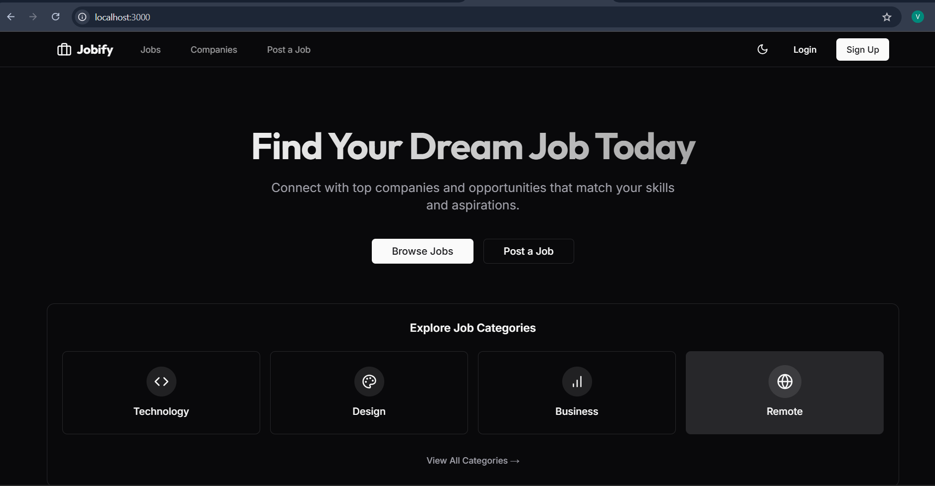

**JOBS PAGE**

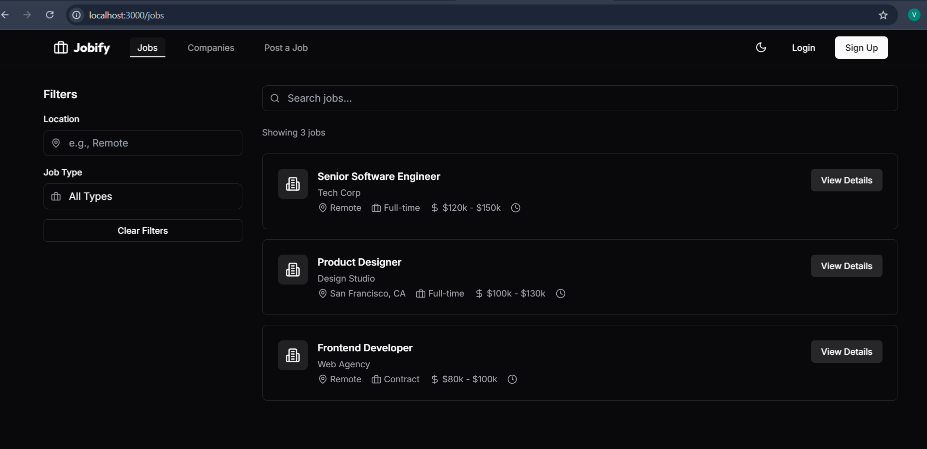

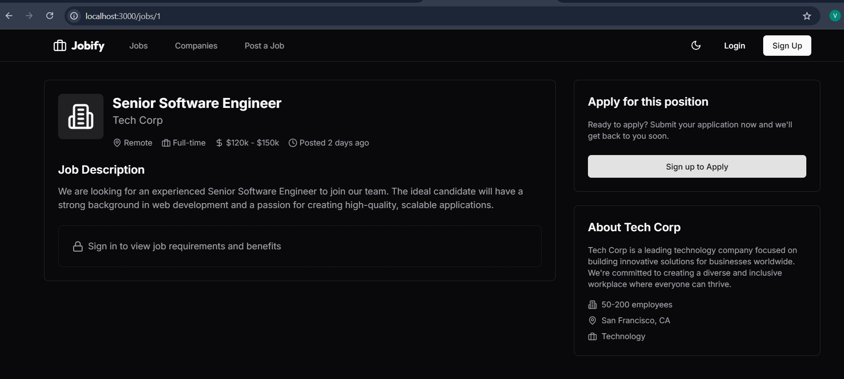

RESTRICTING THE ACCESS TO THE JOB REQUIREMENTS INFO IF THE USER HASN’T CREATED AN ACCOUNT

**COMPANIES PAGE**

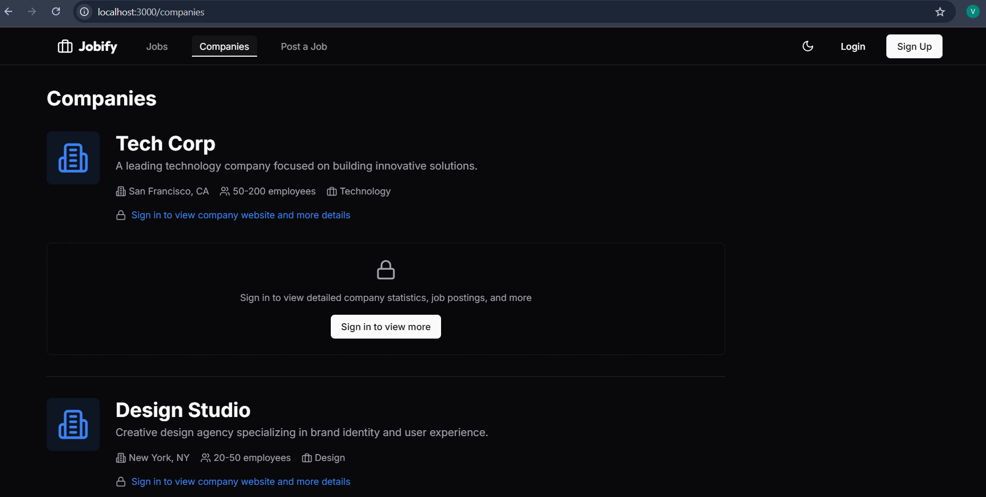

LOWERING THE PRIVILAGES TO KNOW MORE ABOUT THE COMPANY IF THE USER HASN’T CREATED AN ACCOUNT

**POST A JOB PAGE**

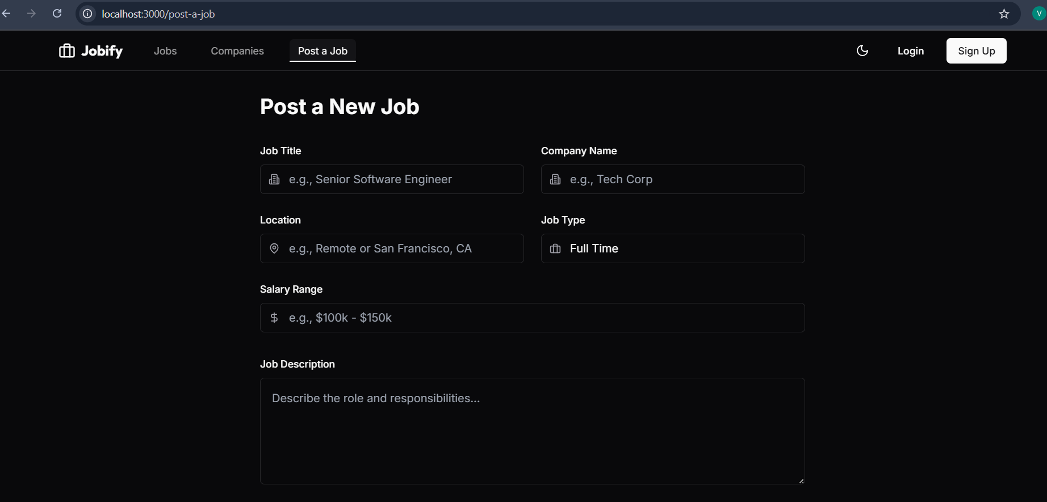

**SIGNUP PAGE**

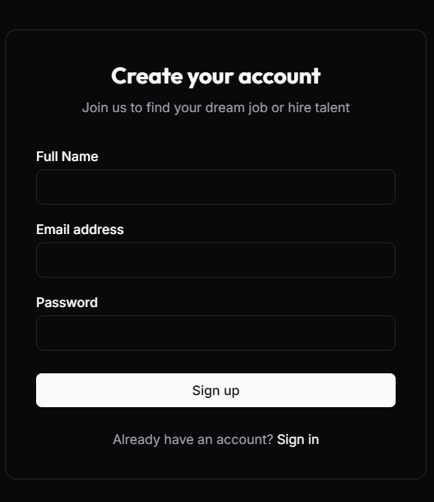

**LOGIN PAGE**

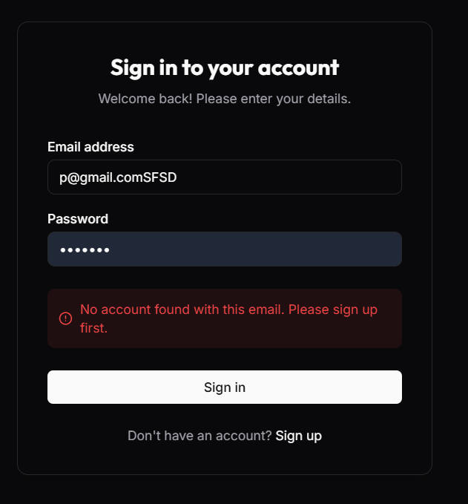

IF THE USER DON’T HAVE AN ACC AND TRY TO LOGIN THEN WARNING MESSAGE WILL APPEAR

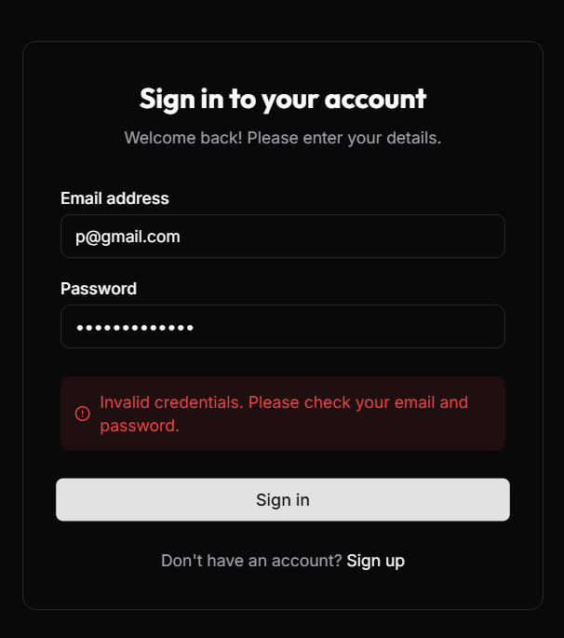

IF THE USER CREDENTIALS ARE INVALID THEN WARNING MESSAGE WILL APPEAR

**MONGODB CONNECTION JUST TO STORE USER LOGIN DETAILS**

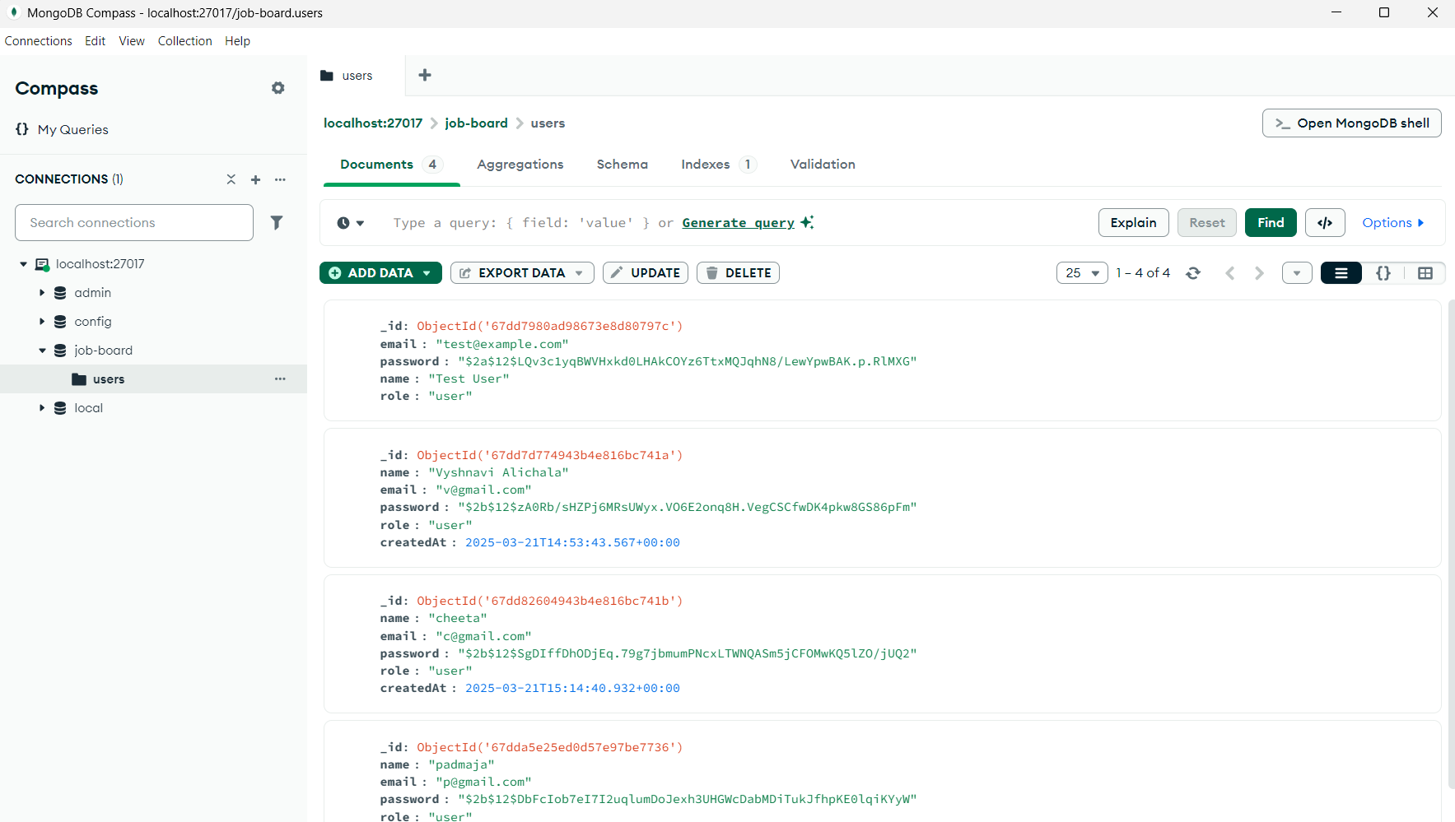

STORING USER LOGIN DETAILS

**AFTER LOGIN**

**HOMEPAGE**

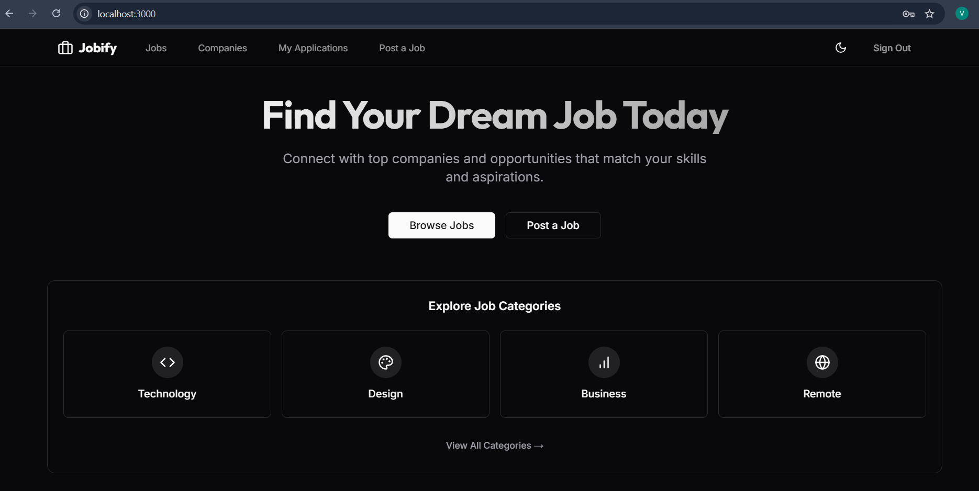

**JOBS PAGE**

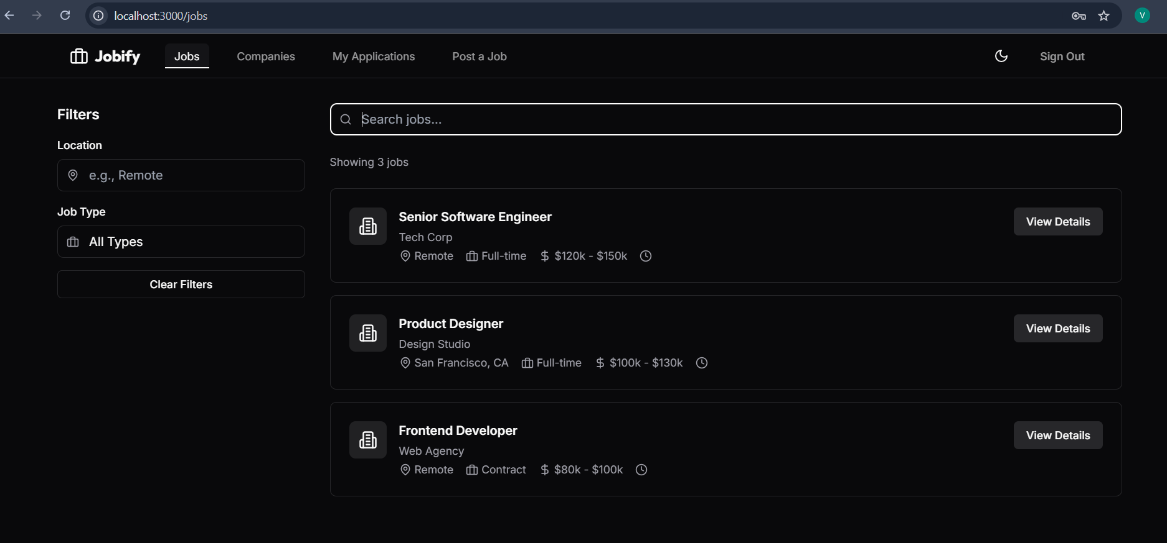

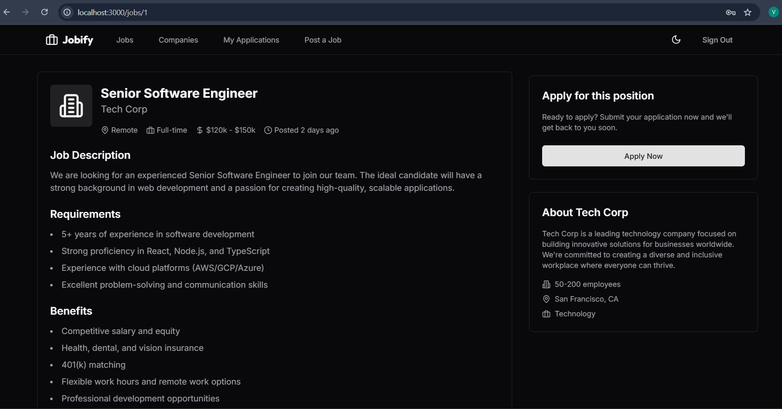

APPEARANCE OF MORE INFORMATION ABOUT JOB AFTER LOGIN

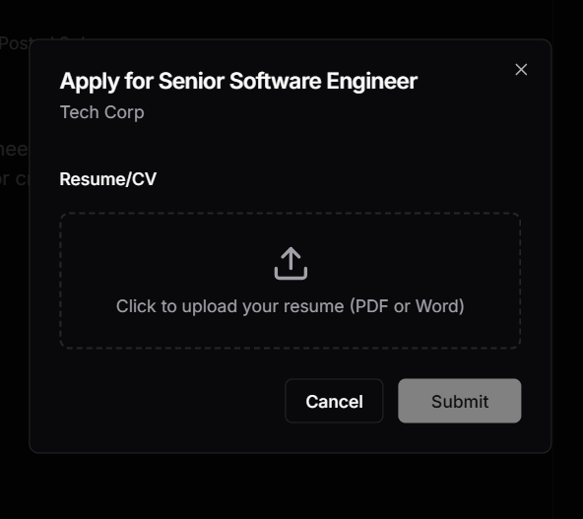

**COMPANIES PAGE**

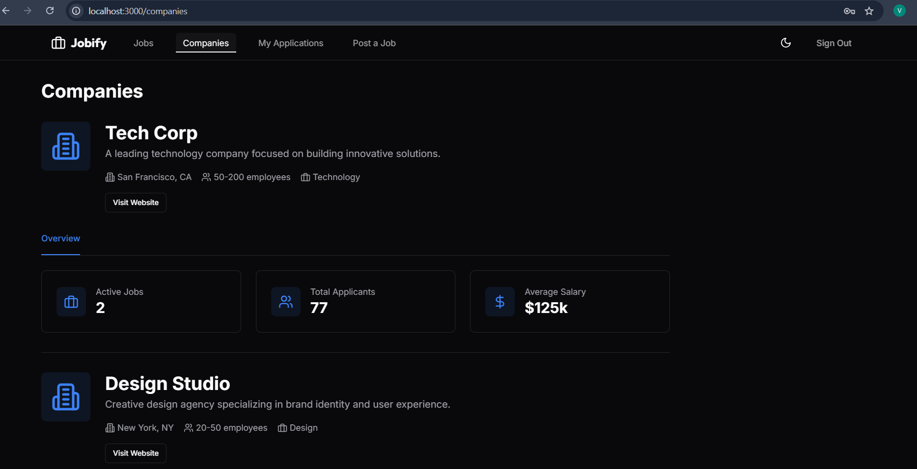

MORE INFORMATION IS DISPLAYED ABOUT COMPANY AFTER LOGIN

**APPLICATIONS PAGE**

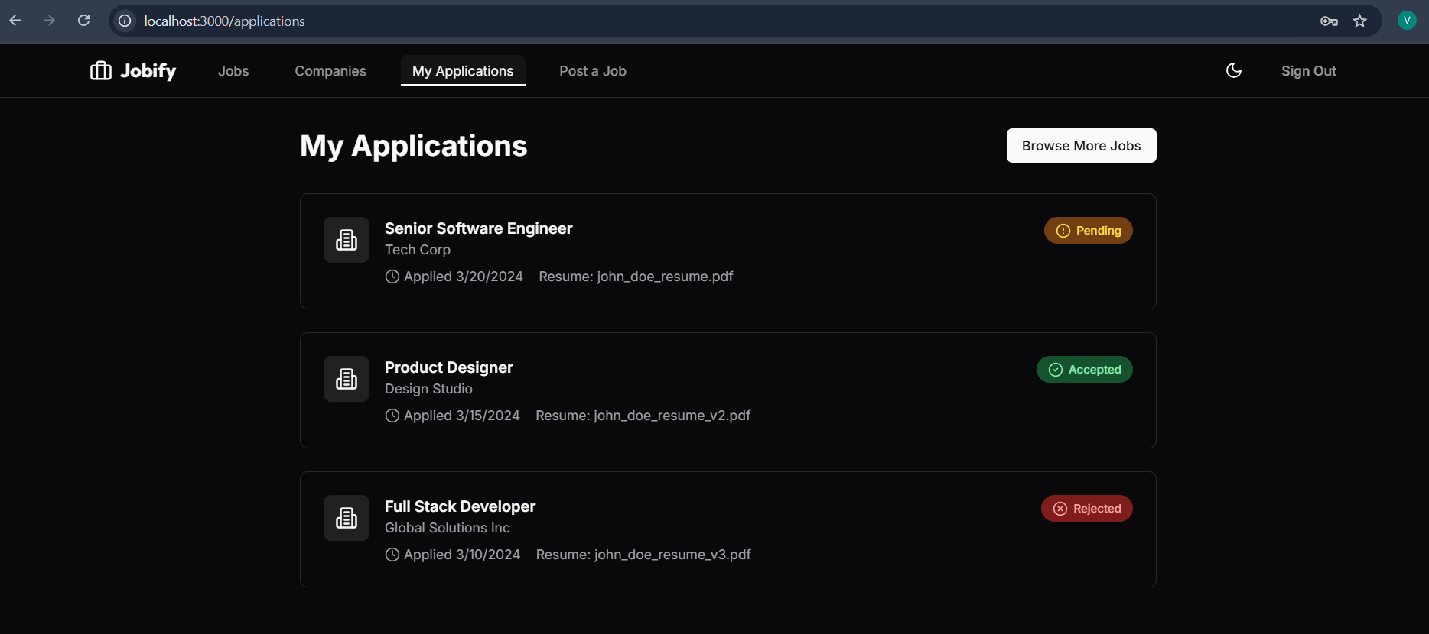

**POST A JOB PAGE**

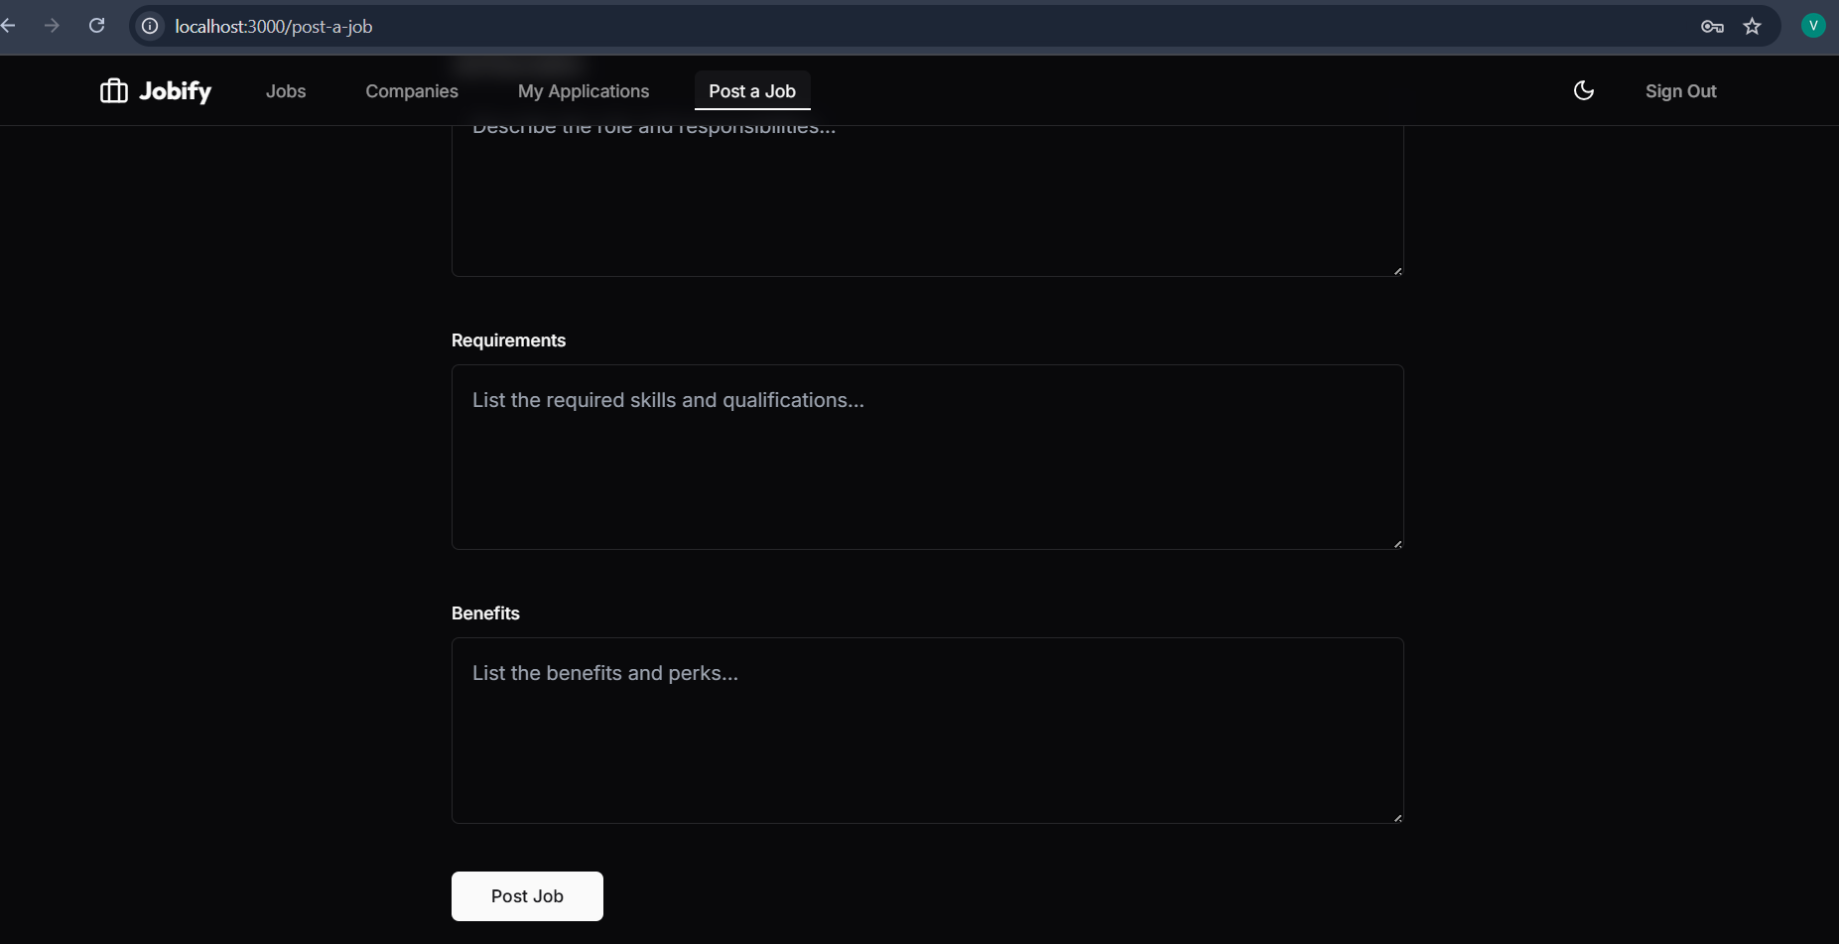

**LIGHT MODE**

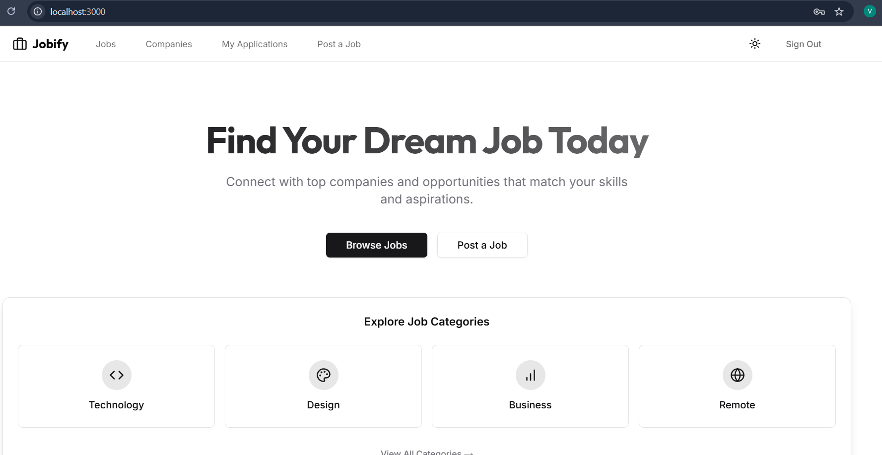

**RESPONSIVENESS**